1. **Which are the different genres?**

SELECT DISTINCT prime_genre

FROM app.applestore

1. **Which is the genre with more apps rated?**

SELECT prime_genre, rating_count_tot

FROM app.applestore

ORDER BY rating_count_tot DESC;

1. **Which is the genre with more apps?**

SELECT prime_genre, COUNT(prime_genre)

FROM app.applestore

GROUP BY prime_genre ;

SELECT prime_genre, COUNT(prime_genre)

FROM app.applestore

GROUP BY prime_genre order by COUNT(prime_genre) DESC;

1. **Which is the one with less?**

SELECT prime_genre, COUNT(prime_genre)

FROM app.applestore

GROUP BY prime_genre ;

**5. Take the 10 apps most rated.**

**6. Take the 10 apps best rated by users.**

**7. Take a look on the data you retrieved in the question 5. Give some insights.**

**8. Take a look on the data you retrieved in the question 6. Give some insights.**

**9. Now compare the data from questions 5 and 6. What do you see?**

**10. How could you take the top 3 regarding the user ratings but also the number of votes?**

**11. Does people care about the price?** Do some queries, comment why are you doing them and the results you retrieve. What is your conclusion?

The excel had some compatability problems I had to do this steps before importing in MySQL:

1. Choose Data and From Text/CSV and the excel file in this case apple.store

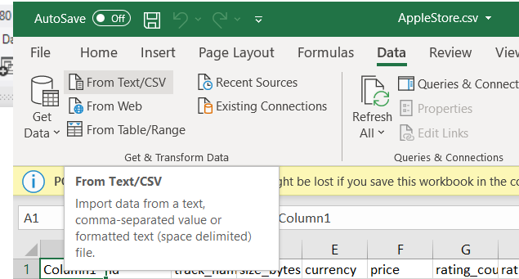

1. Chose US-ASCII because of compatibility with characters so we avoid errors and click load and save in the end

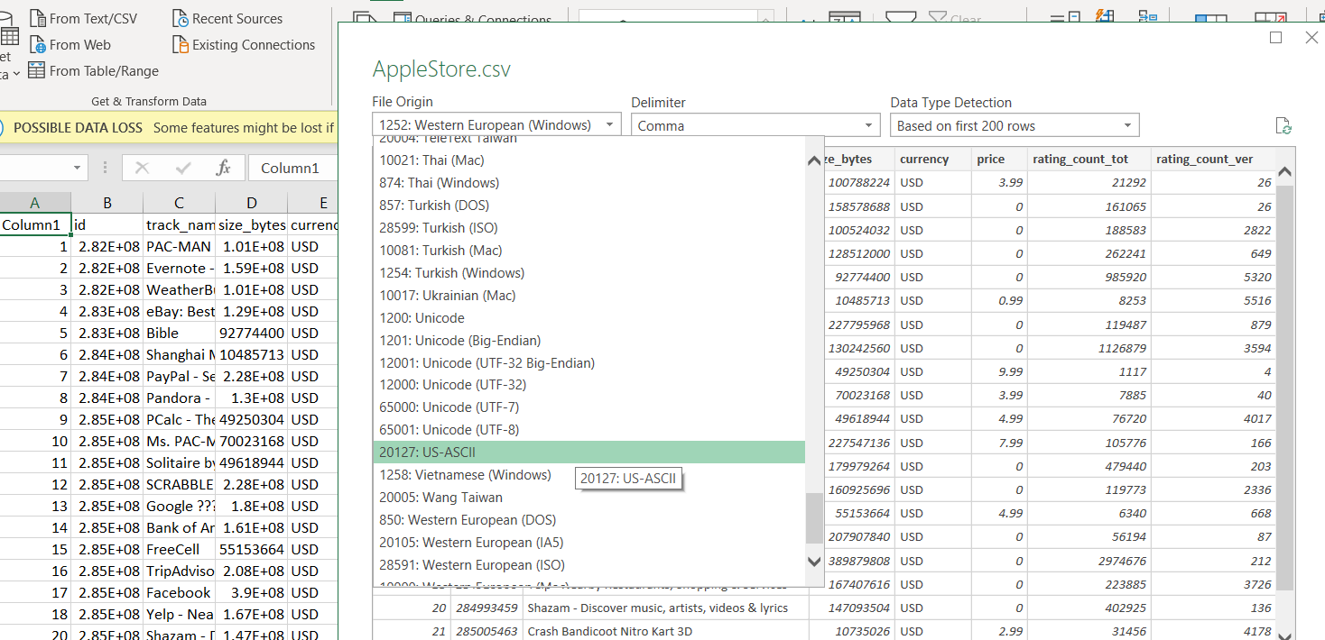

Note: To import a file (CSV) :

1. Open Work bench and create a scheme using the mouse right click I give the name app
2. Then in apps I select with a right click and in the menu will appear wizar import.. I choose and go to the path where the excel file
3. Change the type for bigint

